Mikhail Fedorovich Larionov (1881-1964)
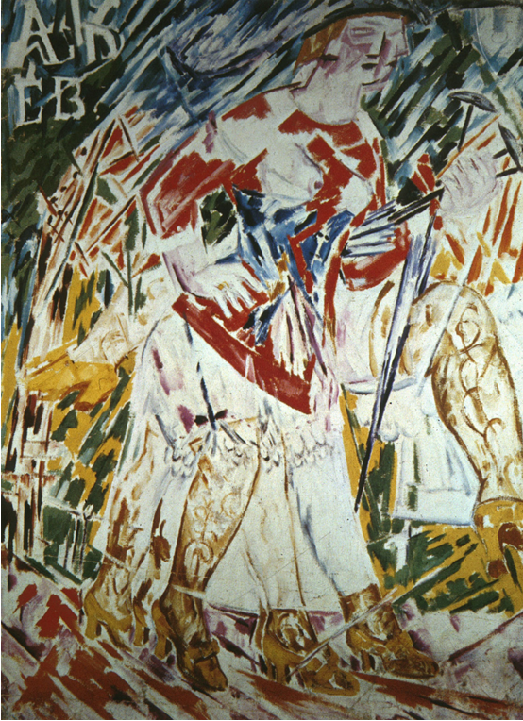

http://www.usc.edu/dept/LAS/IMRC/course_website/slides09/lario005_200w.htm

Mikhail Larionov: Boulevard Venus, 1913, Oil on canvas, 116x86cm. Collection: Musee National d’Art Moderne, Centre Georges Pompidou, Paris.

Image and reproduction rights need to be sought from the Reunion des Musees Nationaux in Paris.

Copyright needs to be sought from ADAGP in Paris, or DACS (representing ADAGP in the UK) or ARS (representing ADAGP in the USA).

Mihail Larionov was the leader of the Russian artistic vanguard in Moscow in the years before the First World War. He was a vivacious and highly talented painter, book illustrator and exhibition organiser. During 1909-1912 he employed a highly distinctive expressonist style of painting called NEO-PRIMITIVISM which, in its frank celebration of popular culture, was calculated to offend polite taste. Subsequently he made his name as a Russian futurist and engaged in an innovative form of abstract and non-objective painting called RAYONISM which prepared the way for Malevich’s SUPREMATISM and Tatlin’s CONSTRUCTIVISM. In 1915 Larionov, along with his partner, the painter Natalia GONCHAROVA, left Russia to work as a stage designer for Diaghilev’s BALLETS RUSSES.

Larionov was born in Tiraspol, then Bessarabia in 1881 and was sent to Moscow for his secondary education. In 1898 he began to study painting at the Moscow School of Art and here he met his future life-long colleague and partner Natalia Goncharova. Larionov reached maturity in 1909 when, having undergone the impact of Paul Gauguin, Vincent van Gogh, Paul Cézanne, Henri Matisse and the Fauves he engaged in a rebarbative style of painting that he subsequently called NEO-PRIMITIVISM. On the one hand these works represented a critique of the artificiality of bourgeois manners (Walk in a Provincial Town, Moscow: Tretiakov Gallery) whilst on the other they celebrated the vitality and authenticiy of a supposed ‘primitiveness’ exemplified by the those considered beyond the parameters of polite borgeois society such as peasants, gypsies, squaddies and prostitutes (Katsap Venus, Nizhny-Novgorod: Art Museum). At the formal level the paintings recall the schematic and expressive forms of the Russian lubok print, Russian icon, signboard paintings, graffiti and children’s art. A cycle of four paintings entitled The Seasons (Moscow: Tretiakov Gallery & Paris: MNAM) was completed in 1913 and represents the apogee of the style.

In 1912 Larionov began to explore the possibilities of CUBISM and FUTURISM in works such as Boulevard Venus (Paris: MNAM) whilst also developing a radical form of abstraction called RAYONISM (Luchizm). A series of brightly coloured non-objective Rayonist Constructions executed in 1913 represented the cutting edge of Russian avant-garde art in the years before the war and paved the way for the subsequently development of SUPREMATISM and CONSTRUCTIVISM. Larionov was also fundamental to the development of the Russian avant-garde at this time as an organizer of controversial art exhibitions. He played a key role in the foundation of the Knave of Diamonds exhibition society (first exhibition Moscow: 1910-11) and subsequently organized The Donkey’s Tail (Moscow, 1912), The Target (Moscow, 1913) and No. 4 (Moscow, 1914) exhibitions which fostered and presented emerging talent. Kazimir MALEVICH and Vladimir TATLIN both reached artistic maturity within these groupings. With Natalia GONCHAROVA, Larionov also founded a Futurist theatre known as Teatr Futu and starred in the very first film to involve the artistic avant-garde: Drama in the Futurists’ Cabaret No. 13 (Moscow, 1913. Director: Kasyanov, no longer extant).

Larionov assisted Goncharova in her designs for Diaghilev’s staging of Rimsky-Korsakov’s Le coq d’or, in Paris in 1914. The two artists also held a retrospective exhibition at the Galerie Paul Guillaume before returning to Moscow on the outbreak of war. Larionov saw active service on the Eastern Front but was wounded in 1915 and invalided out of the army. Suffering from ‘shell-shock’ he never completely recovered his ability to concentrate. He travelled to Switzerland with Goncharova later in the year and joined Diaghilev’s BALLETS RUSSES as a stage designer. His work for Diaghilev included sets and costumes for Soleil de minuit (1915), Chout ou le bouffon (1921), Le Renard (first version 1921, second version 1929). He subsequently staged Massine’s Port Said and Lifar’s Sur le Borysthène. In the years after the war he settled in Paris with Goncharova where he became a leading member of the École de Paris, working as a painter, graphic artist, exhibition organiser and also as Goncharova’s’impressario’ and manager. He died in a care home at Fontenay-aux-Roses, Paris in 1964. He is now widely recognized as one of the leading exponents of Russian modernism alongside artists such as Goncharova, Malevich, Tatlin and Rodchenko.

References and further reading :

Literature:

Eganbiuri, Eli (1913), Natalia Goncharova. Mikhail Larionov, Moscow: Miunster.

George, Waldemar (1966), Michel Larionov, Paris: Bibliothèque des Arts

Kovalev, A. E. (2005), Mikhail Larionov v Rossii 1881-1915, Moskva: Khudozhestevennaia Gallereia Elizium

Kovtun, Evgeniy (1998), Mikhail Larionov, Bournemouth (UK): Parktsone Press

Loguine, T. (1971), Gontcharova et Larionov: 50 Ans à St. Germain-des-Près: Témoignages et Documents, Paris: Éditions Klincksieck

MNAM (Musée National d’Art Moderne, Paris), 1995: Nathalie Gontcharova – Michel Larionov: Collections du Musée National d’Art Moderne, Paris: Centre Georges Pompidou

Parton, Anthony (1993), Mikhail Larionov and the Russian Avant-Garde, Princeton / London: Princeton University Press / Thames & Hudson.

Pospelov, Gleb & Iliukhina, E. (2005), Mikhail Larionov: Zhivopis, grafika, teatr, Moskva: Izd. Galart & Izd. “RA” (Russkiy Avanagard).

Tretiakov Gallery (Moscow) (1999): Mikhail Larionov – Natalia Goncharova: Shedevry is parizhskogo naslediia: zhivopis (major exhibition catalogue)

Warren, Sarah (2013): Mikhail Larionov and the Cultural Politics of Late Imperial Russia, Farnham (UK): Ashgate

